Face Sketch Creation And Recognition

## Prof. Anoop Kushwaha1, Sanket Kale2, Abhishek Gavhane3, Mayur Shinde4, Pramod Rumale5

*1 Assist. Professor, Dept. of Computer Engg., Alard College of Engineering, Pune, Maharashtra*

*2,3,4,5BE students, Dept. of Computer Engg., Alard College of Engineering, Pune, Maharashtra*

***

## Abstract – Abstract – The creation and recognition of face sketches is an essential part of various security and identification systems. Traditional methods of face sketching and recognition involve manual efforts and are prone to inaccuracies. The goal of this project is the automation of face sketch creation and detection, aiming for maximum optimization, abstraction, and security. This implementation consists of a web application designed to assist law enforcement and administrative authorities in accurately generating and recognizing face sketches. The system functions as software accessible throughout the organization with appropriate login credentials. It serves as an application for administrators to manage and process face sketch information. Users logging in should be able to upload images and generate corresponding sketches using automated algorithms. The key feature of this project is the accurate and efficient transformation of facial images into sketches and vice versa. The software ensures the secure preservation of face sketch data and facilitates quick access for recognition and matching activities.

## *Key Words: Face sketches, face sketch creation, face sketch recognition, security.*

# INTRODUCTION

## The human face plays a pivotal role in social interaction and communication, crucial for identifying individuals in various contexts. From interpersonal relationships to advanced technological applications, face recognition significantly enhances both interactions and security measures. Traditionally employed in access control, security systems, and surveillance, face recognition has optimized workflow efficiency and safety protocols. However, the rapid advancement of modern technology necessitates refined methodologies to meet evolving demands.Recent innovations in face sketch creation and detection technology have led to sophisticated algorithms that improve accuracy and efficiency. This technology serves two primary functions: creating accurate facial sketches from images and detecting and recognizing these sketches in various settings. These capabilities are essential for law enforcement and administrative authorities in identifying individuals quickly and accurately.Our research addresses the challenges in face sketch creation and detection by proposing an automated web application solution. This application integrates diverse computational techniques inspired by human perception to ensure robust performance. By combining local image sampling, a self-organizing map (SOM) neural network, and a convolutional neural network (CNN), our approach offers robustness, dimensionality reduction, and partial invariance to factors such as translation, rotation, scale, and deformation.Additionally, we explore alternative techniques such as the Karhunen–Loeve (KL) transform and a multilayer perceptron (MLP) to compare their efficacy with our hybrid model. Through rigorous experimentation and analysis, we demonstrate superior performance, particularly in scenarios with limited training data and variability in facial expressions, poses, and details. Using a comprehensive database of 400 images from 40 individuals, our solution proves scalable and adaptable across real-world applications.

## 

## Scope of the Project

1. Developing automated web application.
2. Enhance accuracy and efficiency in recognition process.
3. Robust and scalable performance.
4. Analysis of overall process of face creation and recognition.

# RELATED WORK

Many researchers have contributed to the fields of fuzzy logic-primarily based total implementations. Also, there have been innumerable contributions to the literature aspects of engineering education. The study says that only about 40% of the students express their satisfaction with the numbers of training given to the students to expand their career opportunities. This is a very significant observation. An interactive education and site device that automates the education and site sports presents many possibilities to elevate the choice ratio. This system intimates job openings for students in various fields, applies to those postings, and invites various organizations to hire students from the college and track the progress of the students. It can generate the listing of short-indexed college students as consistent with HR necessities and their special criteria.

Shital K. Patil. Etl. [01]

Web Portal for Training and Placement Cell. However, in this paper, the placement management system is used as an application for the Training and Placement Officer to manage the placement-related activities and the student can be able to update their profile.

S. Venkatachalam. Etl. [02]

Data Mining Classification and analytical version of prediction for Job Placements the usage of Fuzzy Logic. In this paper, a fuzzy inference machine changed used to expect scholar overall performance and enhance instructional overall performance. This version can determine the connection between scholar success and campus placement.

Dr Siddalingesh S. Navalgund. Etl. [03]

A Novel Logic-Based Controller for Measuring the Effectiveness of Job Placement. This paper deliberates a unique method primarily based totally on fuzzy common sense for measuring the effectiveness of schooling classes in phrases of diverse dimensions, particularly software pacing.

Vijay Yadav. Etl. [04]

Smart Job Recruitment Automation: Bridging Industry and University. The proposed smart job recruitment automation system gives automation in all the processes like Registration, Updating, and Searching. It provides a detailed solution to the existing system problem.

Nur Lailliyah Cintya Dewi [05]

Technology Acceptance Model on Internship Job Placement Recommendation System Based on Naïve Bayes. In this system, an Internship Information System was developed to overcome the problem of technical internalization that arises by predicting the accuracy of industry selection using the Naïve Bayes classification method.

Akshta Bhalgat. Etl. [06]

Job Placement Management System. This system can be used as an application for the Placement Officers in the college to manage the student information regarding placement. Student logging must be capable of adding their non-public and academic data inside the shape of a resume.

Anup Khadsare. Etl. [07]

College Recommendation System using Content-based filtering. This project uses Content-based filtering. That means it is based on the description of the item of the user's liking or we can say a profile of the user's taste.

S. Burnasheva. Etl. [08]

Creation of the Effective System for Students’ and Graduates’ Employment Promotion at the University: ETU “LETI” Experience. IEEE V Forum Strategic Partnership of Universities and Enterprises of Hi-Tech Branches (Science. Education. Innovations). This machine makes use of techniques to beautify employment possibilities for its college students and graduates.

Ajay Shiv Sharma. Etl. [09]

PPS-Placement Prediction System using Logistic Regression. This is used to predict the final grades of students based on their web use feature and can distinguish those students that are at risk among the whole batch of college students hence, tutors can offer suitable steerage promptly.

Oi Mean Foong [10]

Mashup for Knowledge Sharing Paradigm: A Case Study in Undergraduate Industrial Internship Training Program In this paper. The Mashup for Internship Placement (MIP) system for undergraduate students is proposed to integrate disparate data from multiple sources

# METHODOLOGY

The proposed Face Sketch Creation and Recognition System is designed to enhance security measures and identification processes by providing an efficient and reliable method for face recognition. This methodology outlines the system's design, focusing on its online accessibility and the division of its functionality into three main modules: login phase, face creation and recognition, matching.

## Proposed System

This application is an online system that can be accessed within the institution. It includes several key phases and modules :

1. Login Phase
2. Sketch creation and selection
3. Feature extraction
4. Matching process

## Login Phase

The system initiates with the login phase, incorporating a two-step verification process to ensure security. This phase involves the following detailed steps:

**User Authentication:**

Step 1: The user is prompted to enter their username and password. This initial step verifies the user's credentials against the system's database.

Step 2: After successfully entering the correct username and password, the user proceeds to the second verification step.

**Two-Step Verification:**

Verification Code: The system generates a unique verification code, which is sent to the user's registered email or mobile phone. This additional layer of security ensures that only the authorized user can proceed.

Code Entry: The user must enter the received verification code into the system. This step confirms the user's identity, adding an extra layer of protection against unauthorized access.

**Access Granting:**

Upon successful entry of the verification code, the system grants the user access to the application. This multi-factor authentication process significantly enhances the overall security of the system by ensuring that only authenticated users can access sensitive features and data.

## Sketch Creation And Selection

## Once authenticated, users can proceed to the sketch creation and selection phase. This phase provides flexibility and precision in creating or selecting the most accurate representation of the face to be recognized. It includes the following detailed steps:

## Composite Face Sketch: users can opt to generate a composite face sketch using a drag-and-drop feature. This option allows users to select facial features from a predefined set, combining them to form a complete face sketch.

## Feature Selection: The composite face sketch tool allows users to select facial features such as eyes, nose, mouth, and hair from a library of options. Each feature can be dragged and dropped into place on the face template.

## Customization Options: Users can customize each feature by resizing, rotating, and adjusting its position to match the desired appearance. This tool provides a high degree of control over the final composite sketch.

## Layer Management: The system uses layer management to organize facial features, allowing users to easily modify individual elements without affecting others.

## Finalizing the Sketch:

## Review and Confirmation: Once the sketch is complete, users can review their work and make any final adjustments. The system provides a preview feature to view the sketch as it will appear in the matching process.

## Submission: After confirming the accuracy of the sketch, users can submit it for feature extraction and subsequent matching against the database of stored photographs.

## Feature Extraction

## After the user has created or selected a sketch, the system proceeds to the feature extraction phase. This crucial step involves advanced image processing and computer vision algorithms designed to identify and extract unique features from the sketch. These features are essential for accurately matching the sketch against the database of stored photographs.

1. **Matching Process**

After the feature extraction phase, the system moves to the matching process, where the sketch is compared against a database of stored photographs. This step is critical for accurately identifying the individual depicted in the sketch. The matching process is detailed as follows:

**Integration with Amazon Rekognition**

To leverage state-of-the-art facial recognition technology, the system uses Amazon Rekognition. Amazon Rekognition provides powerful image and video analysis capabilities, making it an ideal choice for matching sketches to photographs.

**Database Preparation**

The database of stored photographs is prepared and indexed for efficient retrieval:

Image Upload: All photographs are uploaded to an Amazon S3 bucket, which serves as the storage backend for Amazon Rekognition.

Indexing Faces: Amazon Rekognition indexes the faces in the photographs, creating face metadata that can be quickly searched and matched. This indexing involves detecting and extracting facial features, similar to the feature extraction process for sketches.

**Sketch Feature Conversion**

The feature vector extracted from the sketch is converted into a format compatible with Amazon Rekognition:

Encoding Features: The features are encoded into a JSON object that Amazon Rekognition can process. This includes details such as the coordinates of facial landmarks and descriptors for various facial regions.

Normalization: The feature vector is normalized to match the input requirements of Amazon Rekognition, ensuring consistency and compatibility.

**Matching Algorithm**

Amazon Rekognition employs sophisticated algorithms to match the sketch against the indexed faces in the database:

Face Search: The encoded feature vector of the sketch is submitted to the Amazon Rekognition SearchFacesByImage API. This API searches the indexed faces in the database for matches.

Similarity Scoring: Amazon Rekognition uses deep learning algorithms to compare the features of the sketch with those of the stored photographs. It calculates similarity scores based on the distance between feature vectors. The closer the vectors, the higher the similarity score.

**Result Analysis**

The system analyzes the results returned by Amazon Rekognition: Amazon Rekognition provides a list of the top matches, ranked by similarity score. Each match includes metadata such as the similarity percentage, the face ID, and the location of the face in the photograph.

## 

## System Architecture

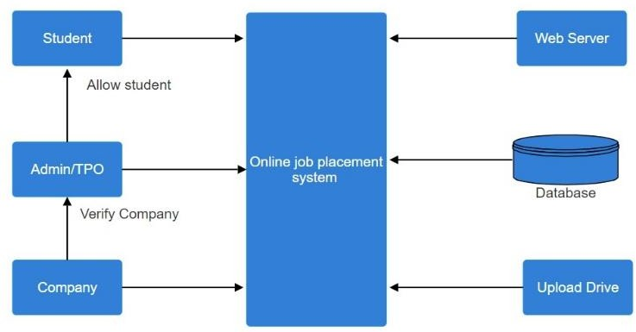

Figure A: System Architecture

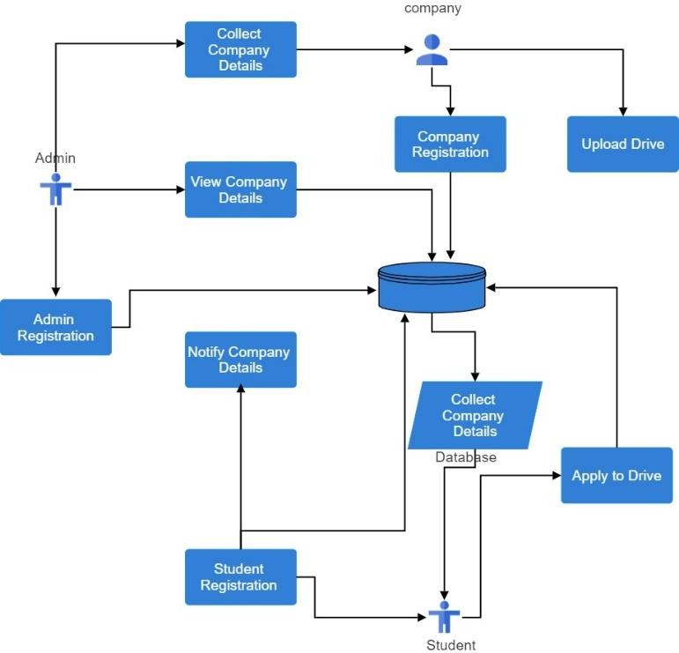

Figure B: System Architecture

# FUTURE SCOPE

# Integration with Additional Databases:

# Expansion of Database Sources: Incorporate more diverse and extensive databases to improve the matching accuracy and robustness. This includes integrating with global databases, law enforcement records, and social media images.

# Real-Time Database Updates: Implement real-time updates and synchronization with external databases to ensure the most current data is available for matching.

# Enhanced Machine Learning Models

# Advanced Deep Learning Techniques: Develop and integrate more advanced deep learning models, such as Generative Adversarial Networks (GANs) for generating more accurate composite sketches and improving feature extraction.

# Transfer Learning: Utilize transfer learning to adapt the system for new environments and datasets with minimal training, enhancing its applicability across different scenarios.

# CONCLUSION

The face sketch creation and recognition system developed in this project offers a significant advancement in biometric identification technology. By integrating a two-step verification process, sophisticated image processing, and state-of-the-art matching algorithms powered by Amazon Rekognition, the system ensures secure and accurate identification of individuals based on facial sketches. This application not only enhances security measures but also provides a valuable tool for various domains such as law enforcement, security, and personal identification. The methodology employed ensures that users can easily create or select accurate representations of faces, and the advanced feature extraction and matching processes enable reliable identification against a comprehensive database. The comprehensive analysis provided by the system gives users a clear understanding of the match's accuracy and reliability, thereby enhancing the system's usability and effectiveness. Looking forward, the project holds immense potential for future enhancements, including the integration of additional databases, the adoption of more advanced machine learning models, and improvements in user interface and scalability.

# RESULT

**The photographs of our project are displayed as follows: -**

**ACKNOWLEDGEMENT**

We are deeply grateful to Professor Anoop Kushwaha Sir for his invaluable mentorship and support during this project. His knowledge and encouragement had been instrumental in shaping our studies journey. We extend our sincere appreciation for his dedication and guidance, which have significantly contributed to our achievements.

# REFERENCES

1. Shital K. Patil (2022). Web Portal for Training and Placement Cell, International Journal of Advanced Research in Science, Communication and Technology (IJARSCT), Volume 2, DOI: 10.48175/568.
2. S. Venkatachalam. (2021). Data Mining Classification and analytical model of prediction for Job Placements using Fuzzy Logic. International Conference on Trends in Electronics and Informatics (ICOEI) | 978-1-6654-1571- 2/21/$31.00 ©2021 IEEE | DOI:

10.1109/ICOEI51242.2021.9452811.

1. Dr. Siddalingesh S. Navalgund (2020). A Novel Fuzzy Logic Based Controller for Measuring the Effectiveness of Training for Placement. Third International Conference on Multimedia Processing, Communication & Information Technology (MPCIT), ©2020 IEEE DOI: 10.1109/MPCIT51588.2020.9350470.
2. Vijay Yadav (2019). Smart Job Recruitment Automation: Bridging Industry and University. [Artificial Intelligence for Transforming Business](https://ieeexplore.ieee.org/xpl/conhome/8933012/proceeding) [and Society (AITB),](https://ieeexplore.ieee.org/xpl/conhome/8933012/proceeding) ©2019 IEEE, DOI: [10.1109/AITB48515.2019.8947445.](https://doi.org/10.1109/AITB48515.2019.8947445)
3. Nur Lailliyah Cintya Dewi (2018). Technology Acceptance Model on Internship Placement Recommendation System Based on Naïve Bayes. [International Conference on Sustainable](https://ieeexplore.ieee.org/xpl/conhome/8685076/proceeding) [Information Engineering and Technology (SIET).](https://ieeexplore.ieee.org/xpl/conhome/8685076/proceeding)

©2018 IEEE, DOI: [10.1109/SIET.2018.8693199.](https://doi.org/10.1109/SIET.2018.8693199)

1. Akshta Bhalgat (2017). Training & Placement Management System, International Engineering Research.Journal (IERJ), Volume 2 Issue 10 Page 4209-4211, 2017 ISSN 2395-1621.
2. Anup Khadsare (2017). College Recommendation System using Content-based filtering, International Journal of Innovative Research in Science, Engineering and Technology, Volume 2 Issue, DOI:10.15680/IJIRSET.2019.0812016.
3. S. Burnasheva (2016). Creation of the Effective System for Students’ and Graduates’ Employment Promotion at the University: ETU “LETI” Experience, [IEEE V Forum Strategic Partnership of](https://ieeexplore.ieee.org/xpl/conhome/7822832/proceeding) [Universities and Enterprises of Hi-Tech Branche](https://ieeexplore.ieee.org/xpl/conhome/7822832/proceeding)s.

©2016IEEE, DOI: [10.1109/IVForum.2016.7835858.](https://doi.org/10.1109/IVForum.2016.7835858)

1. Ajay Shiv Sharma (2014). PPS -Placement Prediction System using Logistic Regression, [IEEE](https://ieeexplore.ieee.org/xpl/conhome/7005022/proceeding) [International Conference on MOOC, Innovation,](https://ieeexplore.ieee.org/xpl/conhome/7005022/proceeding) [and Technology in Education (MITE),](https://ieeexplore.ieee.org/xpl/conhome/7005022/proceeding) ©2014 IEEE, DOI: 10.1109/MITE.2014.7020299.
2. Oi Mean Foong (2012). Mashup for Knowledge Sharing Paradigm: A Case Study in Undergraduate Industrial Internship Training Program, [International Conference on Computer &](https://ieeexplore.ieee.org/xpl/conhome/6289460/proceeding) [Information Science (ICCIS).](https://ieeexplore.ieee.org/xpl/conhome/6289460/proceeding) ©2012 IEEE, DOI: 10.1109/ICCISci.2012.6297240.